LAB 1 — Getting Started with Azure AI Foundry & Creating Your First AI Agent
Duration: 2 Hours
Day: Day 1
Level: Beginner
1. Lab Setup

Sign in to Azure
Open your browser.
Navigate to:
https://ai.azure.com
Navigate to Microsoft Foundry
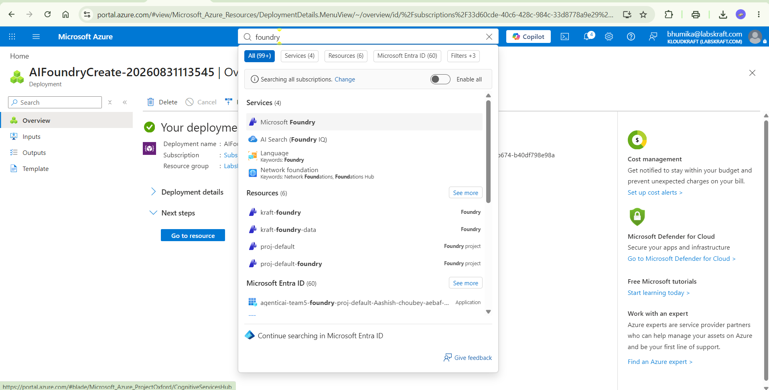
Create Foundry
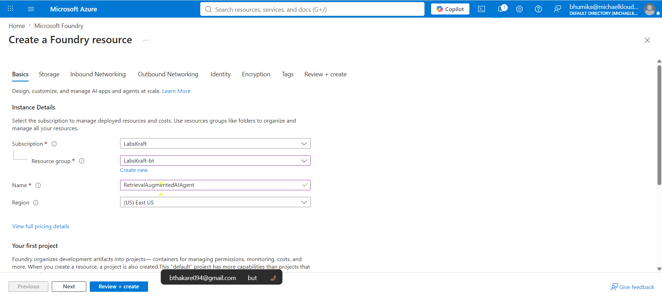
Capture: Azure AI Foundry home page after successful sign-in.
Validation: Azure AI Foundry opens successfully.
The source lab uses Azure AI Foundry as the starting point for the Foundry configuration.

2. Create Azure AI Foundry Project

Create a New Project
From Azure AI Foundry:
- Select Create Project.
- Enter the project name.
- Select your Azure subscription.
- Select or create a Resource Group.
- Select a supported region.
- Select Create.
Example:
Setting | Value
Project Name | AzureAIAgentLab
Subscription | Your Azure Subscription
Resource Group | Lab Resource Group
Region | Supported Azure region

Capture: The Create Project page showing the project name, subscription, resource group and region.
The source lab provides these same project configuration fields.
Verify Project Creation
Wait for the project deployment to finish.
Open the newly created project.
Capture: Successfully created Azure AI Foundry project dashboard.
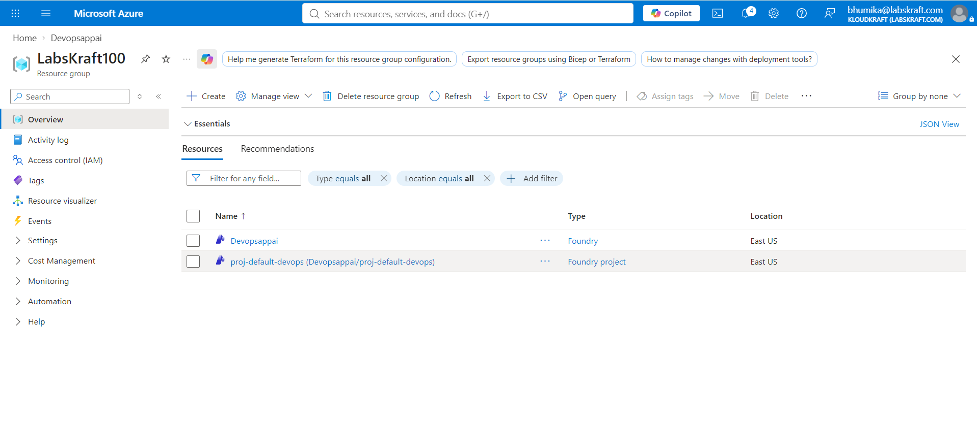
Validation:
- Project is created.
- Project dashboard loads successfully.
The source lab explicitly validates successful project creation and dashboard loading.

3.Deploy the Foundation Model

Open Models + Endpoints
Inside the Foundry project:
- Go to foundry portal
- Select Deployment
- Select Deploy Model.
- Select Deploy Base Model (gpt-5-mini)
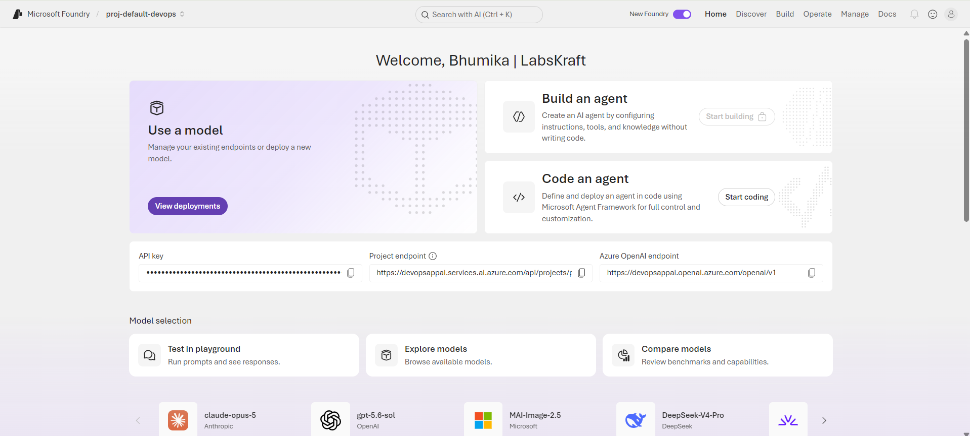
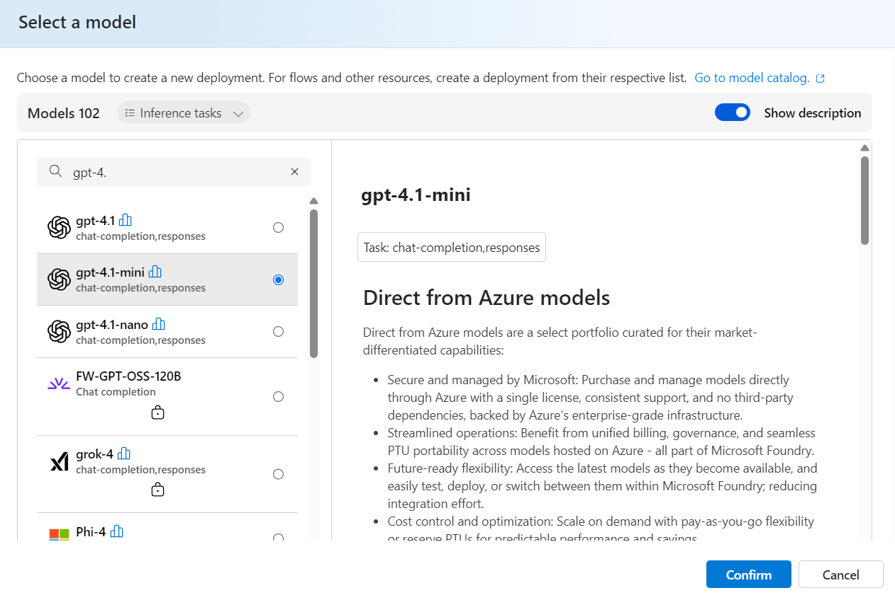
Capture: Models + Endpoints page with the Deploy Model option visible.

Select GPT-5-mini
Search for:
gpt-4.1-mini
Select the model.
Click Confirm.
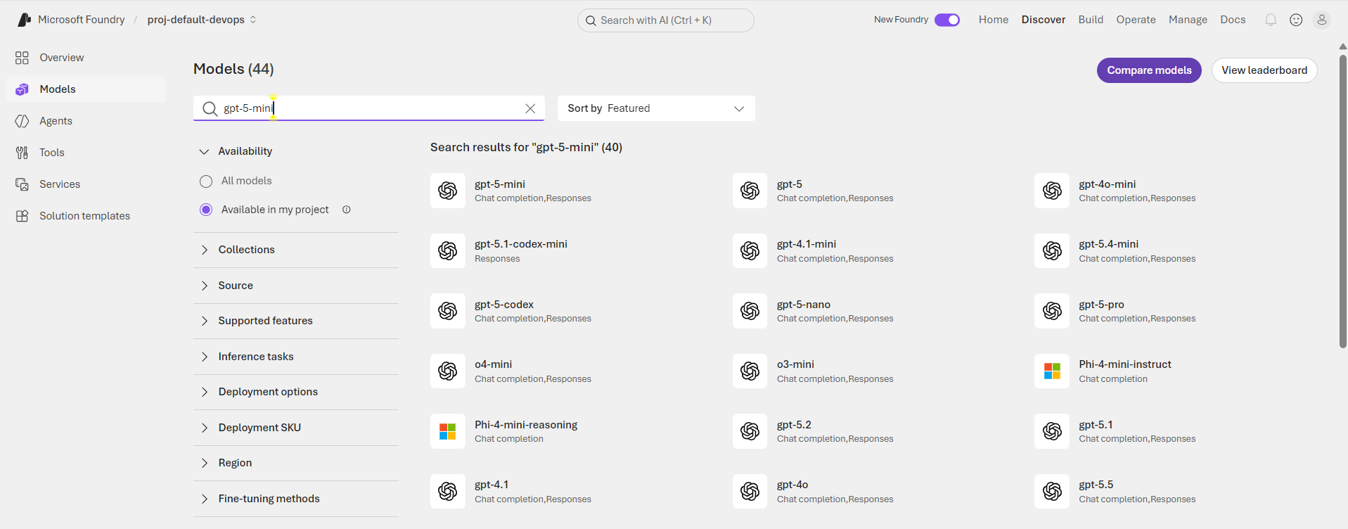
Capture: GPT-4.1-mini selected in the model selection screen.
The source lab specifically uses gpt-4.1-mini.

Configure Model Deployment
Configure:
Setting | Value
Deployment Name | gpt-4.1-mini/gpt-5.4-mini
Model Version | Latest
Deployment Type | Global Standard / supported option
Click Deploy.
Capture: GPT-4.1-mini deployment configuration screen before selecting Deploy.
The source lab specifies the deployment name, version and deployment type.

Verify Deployment
Wait until deployment completes.
The deployment status should show:
Succeeded

Capture: GPT-4.1-mini deployment showing Succeeded.
Validation: Foundation model is successfully deployed.
The source lab uses the Succeeded deployment status as the validation point.
The source lab uses these environment variables for the Foundry connection.

4. Create Your First AI Agent

Step 13 — Open Agent Builder
Return to the Azure AI Foundry project.
From the navigation:
Build → Create Agent
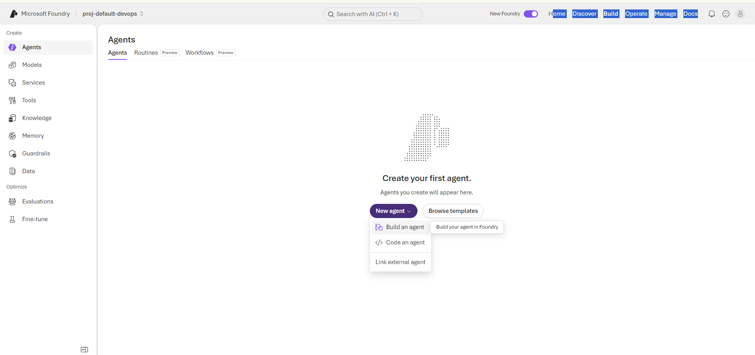

Capture: The Create Agent screen.
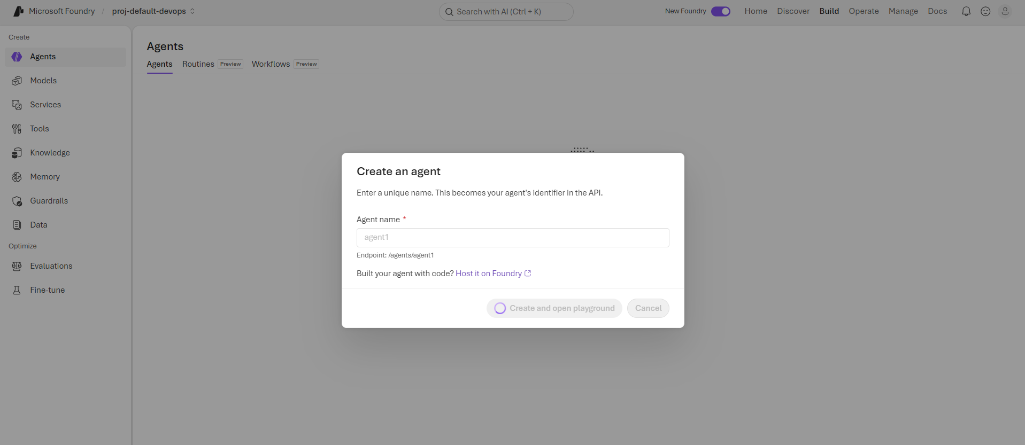
Configure the Agent
Configure the agent:
Setting | Value
Agent Name | MyFirstAIAgent
Model | gpt-4.1-mini
Use the following instructions:
You are a helpful AI assistant.

Answer user questions clearly and accurately.

If you are unsure about an answer, say that you are unsure.
Click Create.
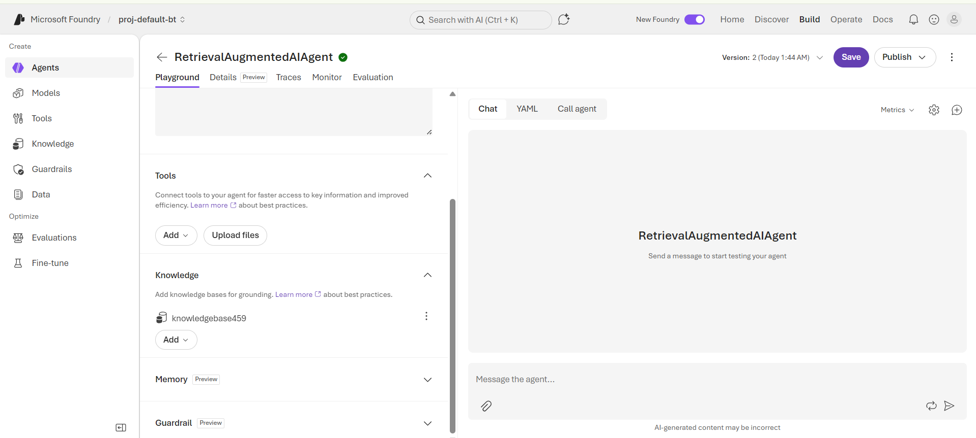
Capture: Agent configuration showing:

- Agent name
- GPT-4.1-mini model
- Instructions
Verify Agent Creation
After creation, open the agent.
Verify that the agent configuration page is displayed.
Capture: The created MyFirstAIAgent in Azure AI Foundry.
Validation:
- Agent exists.
- GPT-4.1-mini is attached.
- Agent configuration is accessible.

5.Test Your First AI Agent

Open Chat / Playground
Open the agent's Chat/Playground interface.
Enter:
Hello! Introduce yourself and explain what you can help me with.
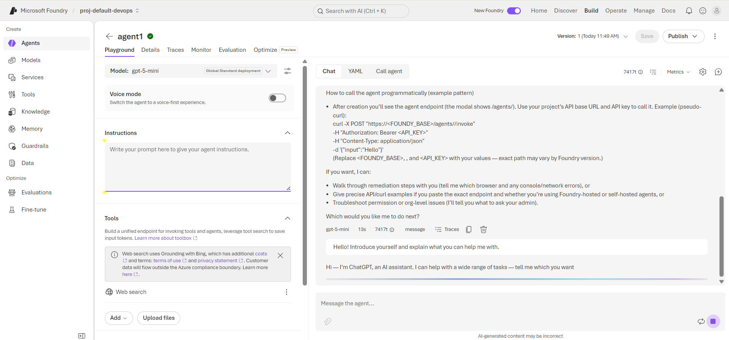

Capture: Agent responding successfully to the prompt.
Test with an AI Question
Enter:
What is Artificial Intelligence?
Capture: The agent's response to the question.
Test LLM Understanding
Enter:
Explain Large Language Models in simple terms.
Capture: Successful response from the agent.

